**Exercise 2: E-commerce Platform Search Function**

**Big O Notation:**

Big O notation describes the upper bound of an algorithm's running time - how performance scales with input size n.

| **Algorithm** | **Time Complexity** | **Meaning** |
| --- | --- | --- |
| Linear Search | O(n) | Time grows linearly |
| Binary Search | O(log n) | Time grows logarithmically |

**Best, Average, Worst Case:**

| **Algorithm** | **Best Case** | **Average Case** | **Worst Case** |
| --- | --- | --- | --- |
| Linear Search | O(1) | O(n/2) ~ O(n) | O(n) |
| Binary Search | O(1) | O(log n) | O(log n) |

**Best Case**: Target found in first attempt.

**Average Case**: Random position.

**Worst Case**: Target not found (scan all).

**Product.java:**

package week1.Algorithms_Data_Structures.EcommercePlatform;

public class Product{

    int productId;

    String productName;

    String category;

    public Product(int productId, String productName, String category){

        this.productId=productId;

        this.productName=productName;

        this.category=category;

    }

    @Override

    public String toString(){

        return productId+" - "+productName+" ["+category+"]";

    }

}

**SearchAlgorithms.java:**

package week1.Algorithms_Data_Structures.EcommercePlatform;

public class SearchAlgorithms {

    public static Product linearSearch(Product[] products, String targetName) {

        for (Product p:products) {

            if (p.productName.equalsIgnoreCase(targetName)) {

                return p;

            }

        }

        return null;

    }

    public static Product binarySearch(Product[] products, String targetName) {

        int left=0;

        int right=products.length-1;

        while (left<=right){

            int mid=left+(right-left)/2;

            Product midProduct=products[mid];

            if(midProduct.productName.equalsIgnoreCase(targetName)){

                return midProduct;

            } else if(midProduct.productName.compareToIgnoreCase(targetName)<0){

                left=mid+1;

            } else{

                right=mid-1;

            }

        }

        return null;

    }

}

**Main.java:**

package week1.Algorithms_Data_Structures.EcommercePlatform;

import java.util.Arrays;

public class Main{

    public static void main(String[] args){

        Product[] products={

            new Product(1, "Laptop", "Electronics"),

            new Product(2, "Chair", "Furniture"),

            new Product(3, "Pen", "Stationery"),

            new Product(4, "Mobile", "Electronics"),

            new Product(5, "Desk", "Furniture")

        };

        Product foundLinear=SearchAlgorithms.linearSearch(products, "Pen");

        System.out.println("Linear Search Result: "+(foundLinear!=null?foundLinear:"Not found"));

        Arrays.sort(products,(a,b)->a.productName.compareToIgnoreCase(b.productName));

        Product foundBinary=SearchAlgorithms.binarySearch(products,"Pen");

        System.out.println("Binary Search Result: "+(foundBinary!=null?foundBinary:"Not found"));

    }

}

**Output:**

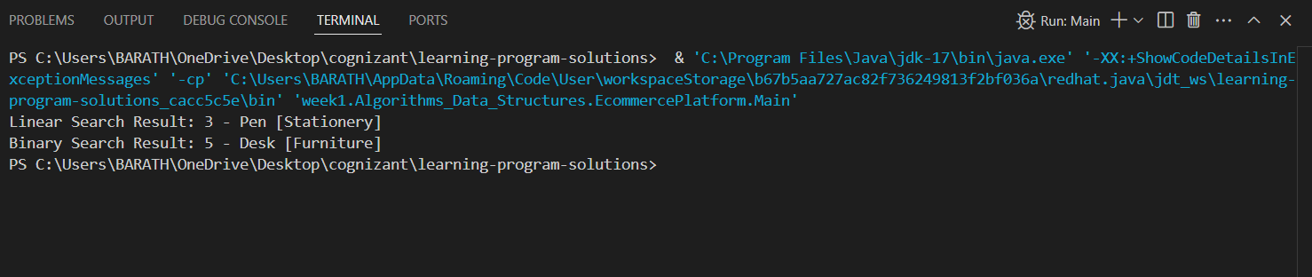

**Analysis:**

Use Linear Search if data is small or frequently unsorted.

Use Binary Search when:

* Data is large
* Rarely modified
* Sorted or can be sorted once during load